Mea Culpa
Roger Beebe and Mickey Johnson
Cell: 209.484.2666

Directions
Village West Marina is located at 6649 Embarcadero, Stockton, CA 95219. For door-to-door directions by land, go to MapQuest.com.
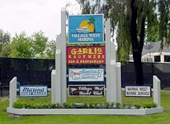
By Land
Village West Marina is conveniently located and easy to find. Take I-5 to Northern Stockton and exit on Benjamin Holt Drive. Turn west onto Benjamin Holt Drive and follow approximately 1 1/2 miles, until you see the large sign at the entrance to Village West Marina on your right.

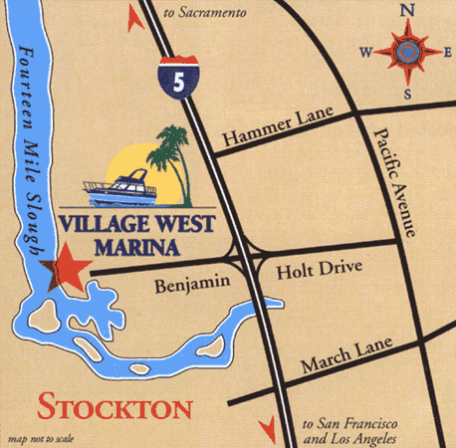

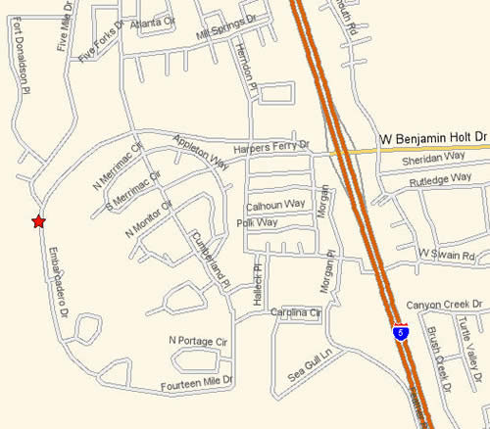

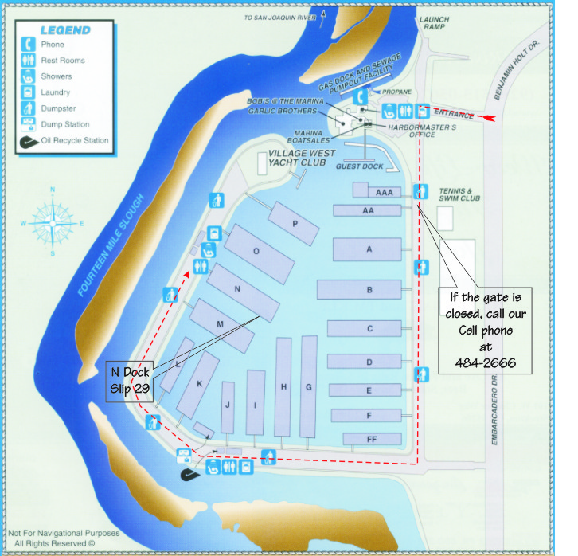
By Water
Turn north off the Stockton Shipping Channel just past buoy number 31. At the major intersection, veer right following Fourteenmile Slough. Village West Marina is at the end of approximately one mile straight southerly stretch of Fourteenmile Slough.

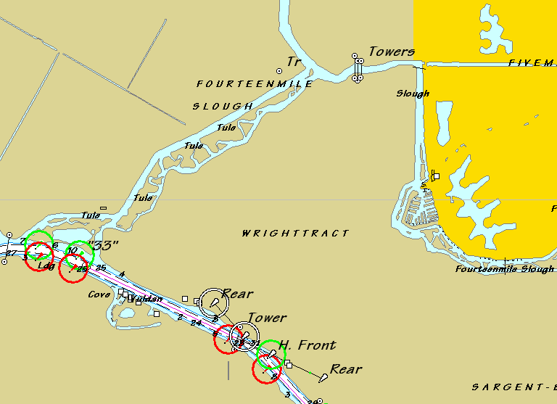
Village West Marina
Village West Yacht Club
33
31

