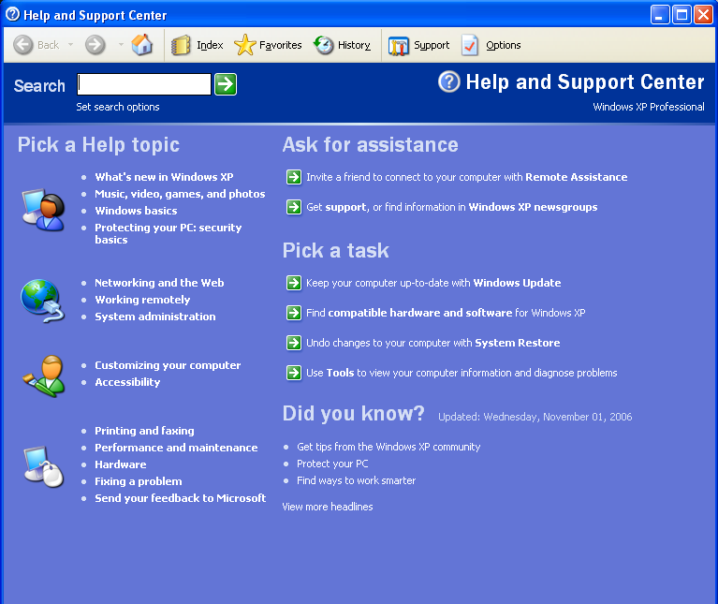
Click on: Invite a friend

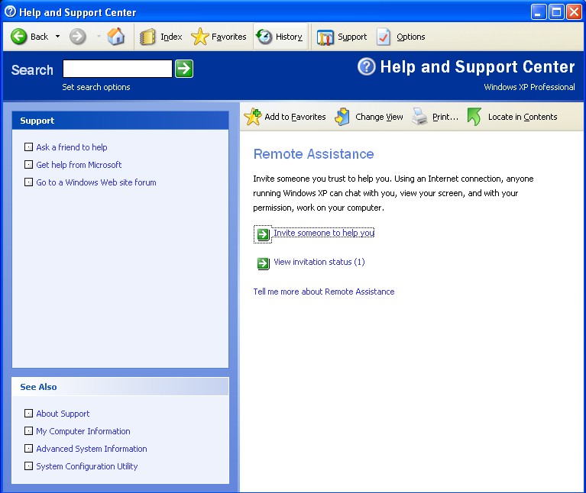
Click on: Invite someone to help you

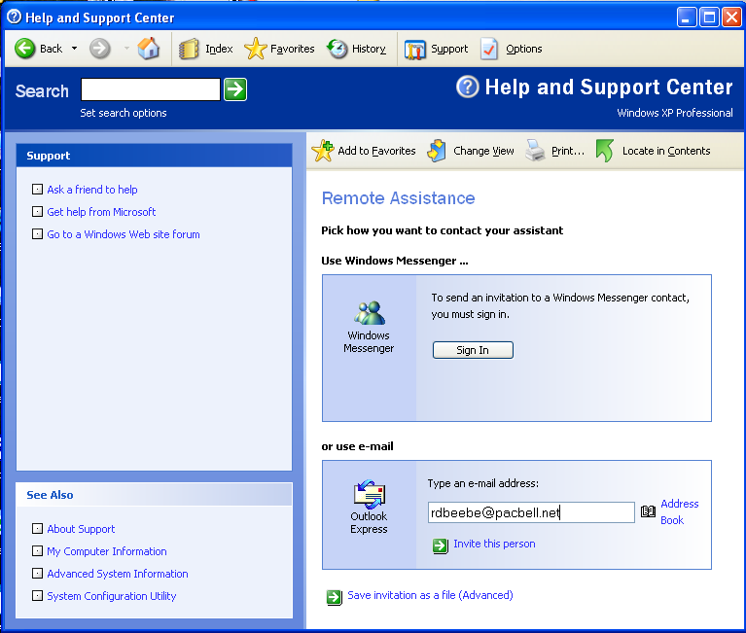
Click on: or use e-mail and use rdbeebe@pacbell.net

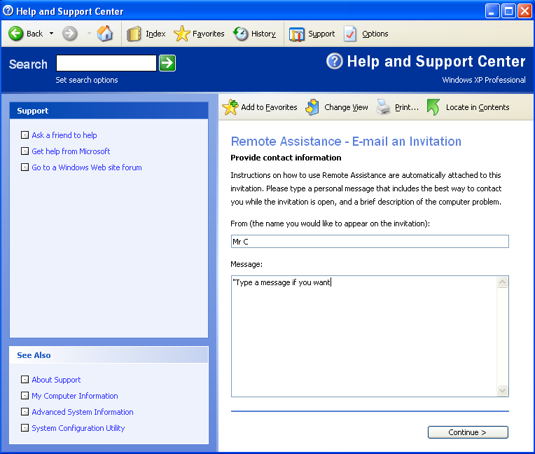
Type your name in the From box.

Type a message if you have a specific question. Then press continue>

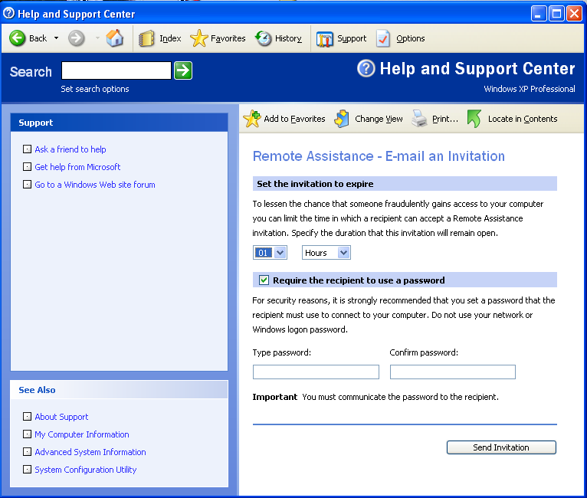
Type the password 1234 and then again to Confirm password.
Then press: Send Invitation
Set the invitation to expire to at least 02 Hours.

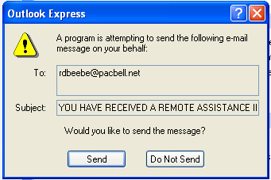
When you click on send invitation, this screen pops up and you must press send to complete the e-mail.

When I accept your invitation you have to allow me to connect by clicking Yes.
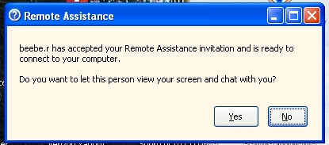

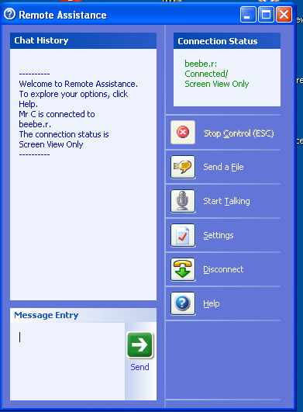

This is the chat screen but we probably will be using the phone. When I take control, I will reduce this window.

When I take control of your screen, you have to click: Yes to give me permission.
